Q1.
Ecologists developed a method for estimating the biomass of trees in a plantation.
The plantation consisted of trees of the same species.
They collected samples of wood from trees. For each sample they:
• determined the density of the freshly cut wood
• dried the wood in an oven at 103 °C for 24 hours
• determined the volume of the dried wood sample
• determined the density of the dried wood.
The table below shows data about one wood sample.

Volume of freshly cut wood sample  / dm³ | Density of freshly cut wood  / g per dm³ | Volume of dried wood sample  / dm³ | Density of dried wood sample  / g per dm³
1.345 | 993.0 | 1.125 | 769.0

(a) The loss of mass of the wood sample was due to loss of water. Water has a density of 1 g per cm³.
Use the data in the table to calculate the percentage of water in the freshly cut wood sample. Show your working.
Percentage of water = _______________________
(2)
(b) The ecologists dried the samples in an oven at 103 °C for 24 hours. Describe how the ecologists could have determined whether or not this drying removed all the water from a sample of wood.
___________________________________________________________________
___________________________________________________________________
___________________________________________________________________
___________________________________________________________________
___________________________________________________________________
(2)
(c) Ecologists then investigated the relationship between the diameter of the trunk of the trees and their biomass.
The graph below shows their results. Each point is the result for one tree.
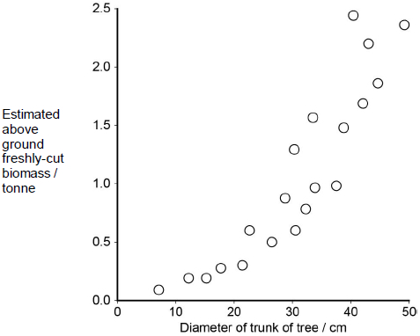
What does the graph show about the relationship between the diameter of the trunk of the trees and their biomass?
___________________________________________________________________
___________________________________________________________________
___________________________________________________________________
___________________________________________________________________
___________________________________________________________________
(2)
(d) Plantations of trees are often created to remove carbon dioxide from the atmosphere, to help to balance the carbon dioxide released by burning fossil fuels.
For different species of tree, information is available for:
• the relationship between diameter of trunk and freshly cut biomass
• the percentage of water in fresh-cut wood
• the mean dried density of wood.
Using only the information provided in part (c), suggest how the mass of carbon in the wood of a plantation of trees of a particular species could be estimated.
Start with measuring the diameter of a large number of trees.
Assume that the dry biomass of a tree consists of biological molecules that contain carbon.
___________________________________________________________________
___________________________________________________________________
___________________________________________________________________
___________________________________________________________________
___________________________________________________________________
___________________________________________________________________
___________________________________________________________________
___________________________________________________________________
___________________________________________________________________
___________________________________________________________________
(4)
(Total 10 marks)
Q2.
Tomato plants were grown in two glasshouses, each with an area of 2000 m². The table shows the mean number of hours of sunshine per month during fruit production.

 | 1995 – 1997  (no extra carbon dioxide | 1998 – 2000  (extra carbon dioxide)
Mean number of hours of  sunshine per month | 148.91 | 147.00

• The scientists used heating to maintain the temperature inside the glasshouses above 18 °C. They opened the windows to keep the temperature below 30 °C.
• From 1998 to 2000 they maintained the carbon dioxide concentration between 0.06 % and 0.08 % when the windows were closed and between 0.04 % and 0.05 % when the windows were open.
• The carbon dioxide concentration in the air outside the glasshouse was 0.04 %.
(a) The scientists monitored the number of hours of sunshine per month. Explain why they monitored the number of hours of sunshine.
___________________________________________________________________
___________________________________________________________________
___________________________________________________________________
___________________________________________________________________
___________________________________________________________________
___________________________________________________________________
(2)
(b) The temperature, the use of fertiliser and the number of insect pests were controlled during this investigation. Name one other factor which should have been controlled during the investigation. Explain why variation in this factor would affect yield.
Factor _____________________________________________________________
Explanation _________________________________________________________
___________________________________________________________________
(2)
(Total 4 marks)
Q3.
In the activated sludge method of sewage treatment, organic matter in untreated sewage supplies nutrients to bacteria in the treatment tank. These bacteria include decomposers and nitrifying bacteria. The bacteria are eaten by ciliated protoctistans, which are, in turn, eaten by carnivorous protoctistans.
(a) (i) Explain the roles of the decomposers and the nitrifying bacteria in converting nitrogen in organic compounds in the sewage into a soluble, inorganic form.
______________________________________________________________
______________________________________________________________
______________________________________________________________
______________________________________________________________
______________________________________________________________
______________________________________________________________
(3)
(ii) Nitrifying bacteria are one kind of bacteria that are important in the nitrogen cycle; nitrogen-fixing bacteria are another kind. Describe the part played by nitrogen-fixing bacteria in the nitrogen cycle.
______________________________________________________________
______________________________________________________________
______________________________________________________________
______________________________________________________________
(2)
(b) The organic matter in untreated sewage consists of small particles, which are suspended in water. Activated sludge consists of solid lumps (flocs) of organic matter and bacteria. When the two are mixed in the treatment tank, bacteria from the flocs become dispersed in the water and feed on the suspended organic matter, converting it to flocs. Different types of ciliated protoctistans feed on the bacteria.
• Free-swimming protoctistans are able to move throughout the tank.
• Crawling protoctistans can only move over the surface of the flocs.
The diagram shows the change in the nature of the organic matter in the treatment tank and the changes in the numbers of the different types of organisms present.
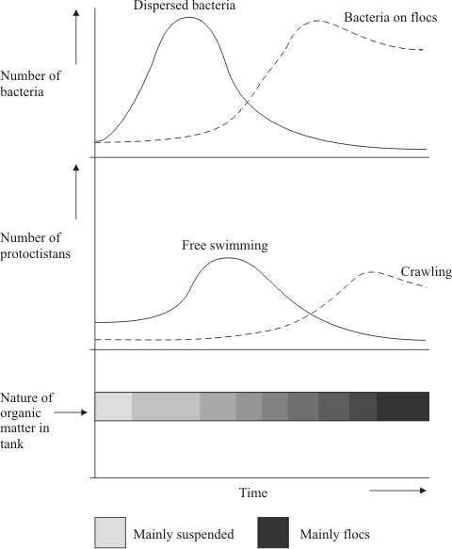
(i) Explain the changes in the numbers of dispersed bacteria and the numbers of free-swimming protoctistans.
______________________________________________________________
______________________________________________________________
______________________________________________________________
______________________________________________________________
______________________________________________________________
______________________________________________________________
(3)
(ii) Explain how the changes that occur in the treatment tank illustrate the process of succession.
______________________________________________________________
______________________________________________________________
______________________________________________________________
______________________________________________________________
______________________________________________________________
______________________________________________________________
______________________________________________________________
______________________________________________________________
(4)
(Total 12 marks)
Q4.
Chloroplasts contain chlorophyll a and chlorophyll b. Scientists found tobacco plants with a mutation that caused them to make more chlorophyll b than normal tobacco plants. They investigated the effect of this mutation on the rate of photosynthesis.
The scientists carried out the following investigation.
• They grew normal and mutant tobacco plants. They grew some of each in low light intensity and grew others in high light intensity.
• They isolated samples of chloroplasts from mature plants of both types.
• Finally, they measured oxygen production by the chloroplasts they had isolated from the plants.
The figure below shows the scientists’ results.
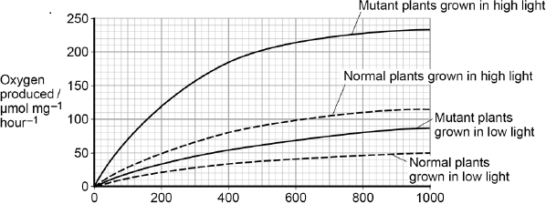
Light intensity / μmol photons m⁻²s⁻¹
(a) Explain why the scientists measured the rate of production of oxygen in this investigation.
___________________________________________________________________
___________________________________________________________________
___________________________________________________________________
___________________________________________________________________
(2)
In each trial, the scientists collected oxygen for 15 minutes.
(b) Calculate the difference in the oxygen produced by the chloroplasts from mutant plants grown in low and high light intensities at a light intensity of 500 μmol photons m^{–2} s^{–1}.
Show your working.

Difference ____________________ μmol O₂ mg^{–1} hour^{–1}
(2)
(c) The scientists suggested that mutant plants producing more chlorophyll b would grow faster than normal plants in all light intensities.
Explain how these data support this suggestion.
___________________________________________________________________
___________________________________________________________________
___________________________________________________________________
___________________________________________________________________
___________________________________________________________________
___________________________________________________________________
___________________________________________________________________
___________________________________________________________________
(4)
(Total 8 marks)
Q5.
Scientists measured the rate of respiration in three parts of an ecosystem.
They did this by measuring carbon dioxide released into the air by:
• leaves of plants
• stems and roots of plants
• non-photosynthetic soil organisms.
The table below shows the scientists’ results for these three parts of the ecosystem.

Part of  ecosystem | Mean rate of  carbon dioxide  production /  cm³ m⁻² s⁻¹ | Percentage of  total carbon dioxide  production measured  by the scientists
Leaves of  plants | 0.032 | 25.0
Stems and  roots of plants | 0.051
Non-  photosynthetic  soil organisms | 0.045

(a) Complete the table to show the percentage of total carbon dioxide production by each part of the ecosystem.
Show your working.

(2)
(b) A student who looked at the data in the table concluded that plants carry out more respiration than non-photosynthetic organisms in the ecosystem.
Use the information provided to suggest why these data may not support the student’s conclusion.
___________________________________________________________________
___________________________________________________________________
___________________________________________________________________
___________________________________________________________________
(2)
(c) What measurements would the scientists have made in order to calculate the rate of carbon dioxide production?
___________________________________________________________________
___________________________________________________________________
___________________________________________________________________
___________________________________________________________________
(2)
(d) The scientists calculated the mean rate of carbon dioxide production of the leaves using measurements of carbon dioxide release in the dark.
Explain why they did not use measurements taken in the light.
___________________________________________________________________
___________________________________________________________________
___________________________________________________________________
___________________________________________________________________
(2)
Another group of scientists measured the mean rate of respiration in soil under trees and soil not under trees in the same wood. They also measured the mean rate of photosynthesis in the trees.
They took measurements at different times of day during the summer.
The figure below shows the scientists’ results.
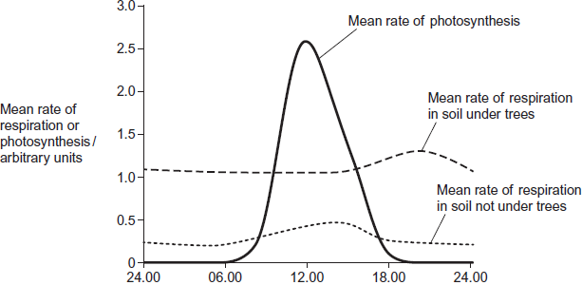
Time of day
(e) (i) Describe two ways in which the mean rate of respiration in soil under trees is different from soil not under trees.
1. ____________________________________________________________
______________________________________________________________
2. ____________________________________________________________
______________________________________________________________
(2)
(ii) Suggest one explanation for the differences in the mean rate of respiration in soil under trees and soil not under trees between 06.00 and 12.00.
______________________________________________________________
______________________________________________________________
______________________________________________________________
______________________________________________________________
(2)
(f) The scientists suggested that the rise in the mean rate of photosynthesis was the cause of the rise in the mean rate of respiration in soil under trees.
(i) Suggest how the rise in the mean rate of photosynthesis could lead to the rise in the mean rate of respiration in soil under trees.
______________________________________________________________
______________________________________________________________
______________________________________________________________
______________________________________________________________
(2)
(ii) Suggest why there is a delay between the rise in the mean rate of photosynthesis and the rise in the mean rate of respiration.
______________________________________________________________
______________________________________________________________
(1)
(Total 15 marks)
Q6.
Mountains are harsh environments. The higher up the mountain, the lower the temperature becomes. The diagram shows a forest growing on the side of a mountain.
The upper boundary of the forest is called the tree line. Trees do not grow above the tree line.
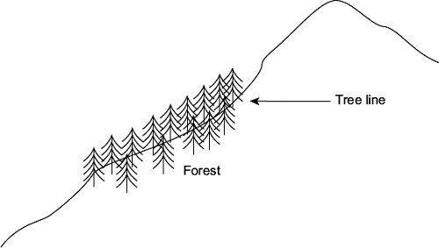
(a) (i) The position of the tree line is determined by abiotic factors.
What is meant by an abiotic factor?
______________________________________________________________
______________________________________________________________
(1)
(ii) Other than temperature, suggest one abiotic factor that is likely to affect the position of the tree line on the mountain.
______________________________________________________________
(1)
(b) Scientists measured the concentration of carbon dioxide in the air in one part of the forest. They took measurements at different times of day and at two different heights above the ground. Their results are shown in the bar chart.
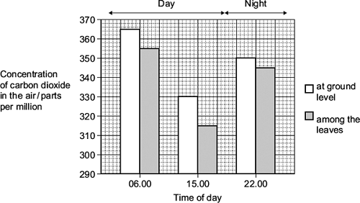
Use your knowledge of photosynthesis and respiration to explain the data in the bar chart.
___________________________________________________________________
___________________________________________________________________
___________________________________________________________________
___________________________________________________________________
___________________________________________________________________
___________________________________________________________________
___________________________________________________________________
___________________________________________________________________
(4)
(c) The population of trees in the forest evolved adaptations to the mountain environment.
Use your knowledge of selection to explain how.
___________________________________________________________________
___________________________________________________________________
___________________________________________________________________
___________________________________________________________________
___________________________________________________________________
___________________________________________________________________
(3)
(Total 9 marks)
Q7.
In some countries, pigs are reared in intensive units in which the temperature is controlled. Agricultural scientists investigated the effect of temperature on pig growth and on the efficiency with which the pigs converted food to biomass.
(a) (i) In the investigation, the scientists used pigs of the same breed, with similar genotypes.
Explain why.
______________________________________________________________
______________________________________________________________
______________________________________________________________
______________________________________________________________
______________________________________________________________
(2)
(ii) The pigs were allowed to eat as much food as they wanted.
How could this have decreased the reliability of any conclusions drawn from the investigation?
______________________________________________________________
______________________________________________________________
______________________________________________________________
______________________________________________________________
______________________________________________________________
(2)
The table shows the results of this investigation.

Temperature / °C | Mean growth rate /  kg per day | Efficiency of conversion of  food to biomass /%
0 | 0.54 | 19
10 | 0.80 | 42
20 | 0.85 | 48
30 | 0.45 | 37
35 | 0.31 | 37

(b) (i) Describe the effect of temperature on mean growth rate.
______________________________________________________________
______________________________________________________________
______________________________________________________________
(1)
(ii) A student concluded from these data that the mean growth rate of the pigs was fastest at 20 °C.
Do you agree with this conclusion? Explain your answer.
______________________________________________________________
______________________________________________________________
______________________________________________________________
______________________________________________________________
______________________________________________________________
(2)
(c) (i) Pigs can survive at temperatures above 35 °C. Use the data to suggest why scientists did not carry out any investigations at temperatures higher than 35 °C.
______________________________________________________________
______________________________________________________________
______________________________________________________________
______________________________________________________________
______________________________________________________________
(2)
(ii) The efficiency of conversion of food to biomass is lower at 0 °C than it is at 20 °C.
Suggest an explanation for the lower efficiency.
______________________________________________________________
______________________________________________________________
______________________________________________________________
______________________________________________________________
______________________________________________________________
(2)
(d) Pigs require a mixture of fibre and protein in their food. The greater the ratio of fibre to protein, the less the food costs.
Scientists took five large groups of pigs. They fed each group a different high-fibre food. Each of the foods contained fibre from different plant species, but they all had the same energy content. The scientists fed a control group of pigs a low-fibre food with the same energy content. After 10 days, the scientists compared the masses of the pigs fed on high-fibre food to those fed on low-fibre food.
The graph shows the results of the investigation. The bars represent ±2 standard errors of the mean.
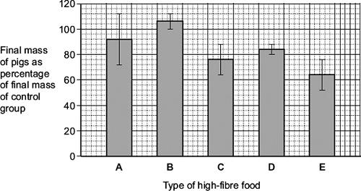
A farmer saw these results and concluded that he should replace his pigs’ usual food with food B.
Evaluate this conclusion.
___________________________________________________________________
___________________________________________________________________
___________________________________________________________________
___________________________________________________________________
___________________________________________________________________
___________________________________________________________________
___________________________________________________________________
___________________________________________________________________
(4)
(Total 15 marks)

